**SYNOPSIS**

**Report on**

**<<HEALTH MONITORING USING IoT>>**

**by**

<<Sakshi Tyagi>> <<2000290140110>>

<<Shivani Chauhan>> <<2000290140114>>

<<Mukul Dhama>> <<2000290140073>>

**Session:2021-2022 (4th Semester)**

Under the supervision of

**Prof. R. N. Panda <<Professor >>**

**Mr. Ankit Verma <<Asst. Professor >>**

### KIET Group of Institutions, Delhi-NCR, Ghaziabad



### Department Of Computer Applications

**KIET GROUP OF INSTITUTIONS, DELHI-NCR, GHAZIABAD-201206**

(march- 2022)

**ABSTRACT**

Diabetes patient monitoring systems play an important role in monitoring patient health, especially when using Internet of Things (IoT) devices. The Diabetes Monitoring System can basically monitor diabetics and store data on blood glucose, temperature, and location. The role of this system is not only to monitor patients but also to classify data using machine learning techniques.

Predictive analytics for diabetics are very important as it helps diabetics, their families, doctors, and medical researchers make decisions about diabetics based on a high amount of data. This white paper describes a new system for monitoring diabetic patients and describes predictive analytics using four different machine learning algorithms. Describes and compares the performance and accuracy of the algorithm used to select the best in terms of multiple parameters.

Diabetes is a condition in which occurs when the body cannot use glucose normally. Glucose is the usual source of Body Cell Essence. Blood levels of glucose are caused by a hormone called insulin produced by the pancreas. There are basically two types of diabetes. Patients with type 1 diabetes and patients with type 2 diabetes. In patients with type 1 diabetes, the pancreas is persistently unable to produce insulin, and in patients with type 2 diabetes, the pancreas produces insulin and does not carry sufficient insulin or does not function. Today, type 1 diabetes is a widespread and prominent clinical problem. Current methods use methods other than snooping, and patient-tolerant data is typically sent to specialists using the IOT. Therefore, the proposed approach captures the blood glucose levels of diabetics, especially for robotized diabetics who check the structure in the ICU. The proposed method, which is close to the ketone level, measures the amount of SnortCH3) 2CO levels when the patient inhales into the demonstration gas sensor. The system uses to list whether your blood sugar is low or high. This structure reflects patient statistics addressed to authorities via WIFI daily in the cloud for future explanations with specific results.

Keywords: 3-5 Keywords

**TABLE OF CONTENTS**

1. Introduction 4
2. Literature Review 5
3. Project / Research Objective 6
4. Research Methodology 7
5. Project / Research Outcome 8
6. Proposed Time Duration 11

References 12

**INTRODUCTION**

Available clinical records show that type 1 diabetes is a notable clinical problem worldwide. There are about 2.6 million adults over the age of 18 suffering from diabetes, and the severity of diabetes should increase in Malaysia. Ketones are artificial substances that appear in the body when the muscle-to-fat ratio is used, as opposed to glucose due to urgency. This indicates that the body's cells cannot absorb enough sugar (glucose) from the blood, especially if the body's insulin is too low. Insulin is used by the body to use glucose, which focuses on what is important. In this sense, which screens ketone zookeepers one by one, helps control and screen the condition of diabetics with a vast number of ketones that remain wild in diabetics. Anyway, the two steps were considered intrusive, horrifying, and anomalous. CH3) 2CO is abstractly recognized by the method of diabetes biomarkers. CH3) 2CO stands for traditional stuff and knows the technology for Ketobetix and the fragrant scent of breathing in diabetics. The combination of breath CH3) 2CO is associated with glucose absorption and lipolysis. This is the method by which attachment to CH3) 2CO respiration is presented in the elevated modern form of diabetes and can be used to study the development of diabetes is called the easiest way and diabetes. Prevents rapid detection of sex ketoacidosis Type 1 diabetes. A method of checking ketone levels is performed using breath estimation. Atem presents a simple portable. Today, there are several chronic illnesses such as heart disease, stroke, cancer, chronic respiratory illness, and diabetes. It is a dangerous disease and has recently become one of the leading causes of death worldwide and requires careful monitoring to maintain patient health. The biggest challenge for diabetics is to raise or lower blood glucose within a specific interval, as diabetes is caused by insulin resistance and inadequate insulin production can lead to level up or level down of blood glucose. If these conditions are not met, some patients may need urgent medical care to avoid exacerbations[1] human management for checking diabetes levels. The strategy presented demonstrated advances in the hardware relationship with the Internet of Things (IoT) system to enhance patient evaluation and individual observation methods. The Arduino board will be used to study the sensor with breath detection capability. Breath observation levels are recorded on the system using distant correspondence. Data collection is linked to the site page. Ketone levels are assessed as the percentage of CH3) 2CO in exhaled breath accumulated when the patient breathes into a mouthpiece containing a gas sensor. This assessment is based on detecting the patient's blood glucose level by separating CH3) 2CO levels from respiration at and sending data to clinical authorities by the WIFI method via a message. These devices are a new way of continuous monitoring. They provide real-time information about blood glucose levels. This article introduces an intelligent diabetes monitoring system using the node MCU and machine learning algorithms. The MCU node is connected to a glucose meter and periodically records the blood glucose levels of diabetics. This collected data can be used by caregivers (patients, researchers, and doctors) to remotely monitor patients. As a result, patients and physicians alike need to process multiple records, interpret vast amounts of data, adjust insulin doses, and bring blood glucose levels as close to normal as possible.

**LITERATURE REVIEW**

This segment discusses the literature overview evaluation of a few papers when it comes to cell utility for diabetic affected persons tracking the use of machine-getting to know algorithms. A description of the proposed structures and the used algorithms on these paintings are given. In their paintings, the authors supplied a smart structure for the surveillance of diabetic ailment that displays the fitness of diabetic sufferers through sensors incorporated into smartphones [2]. In some other paintings, the prediction of diabetes sorts the use of evaluation algorithms and Hadoop map-lessen, prediction of complications, and the prediction of the kind of remedy had been investigated [3], at the same time as in [4], the authors proposed a machine which could carry out predictions for Mellitus that's a form of diabetes the use of Hadoop/MapReduce. A new machine for the prediction of glucose awareness has been proposed in. Where the facts generated via way of means of the Continuous Glucose Monitoring may be analysed via way of means of the glucoSim software program the use of the Kalman Filter (KF) to reducing noise. Many researchers have used different data mining techniques to develop and implement different analytical and predictive models. In [5], the author found a pattern in the Diabetes dataset using the classification method by Naive Bayes and the decision tree algorithm using the Weka tool. In [6], the author uses naive Bayes and decision trees in a model classification technique to examine the hidden patterns in the diabetes dataset. The authors of [7] predicted patient diabetes using the C4.5 decision tree algorithm, Neural network algorithm, Kmeans clustering algorithm, and visualizations.

**PROJECT / RESEARCH OBJECTIVE**

In this part, we will introduce the proposed system. This is a diabetes monitoring system based on a node MCU. The system consists of three parts: a sensor part for data collection, a data analysis part, and the processing of the collected data. The diabetes monitoring system uses a glucose sensor to measure glucose levels in diabetics, and the collected data is sent to a database using a node MCU that uses the IoT platform for storage and processing increase. The measurement data is classified into and analyzed by machine learning algorithms. The results of the classification will be sent to the doctor to check the readings while sending a message to the patient in an emergency.

**RESEARCH METHODOLOGY**

The mechanized diabetes testing system is, which is used to consistently record the blood glucose levels of diabetics, especially in the intensive care unit. The observation frame records glucose levels via a blood glucose sensor. Information will be sent to the Specialist via WIFI. This frame is the moment, which indicates the blood glucose level regardless of whether glucose is falling or rising. The framework provides accurate results and patient information is updated daily in the cloud.

**ARDUINO UNO ATMEGA 328P:**

Arduino microcontroller is something however tough to utilize, open supply, and its device is smart period. The Arduino ATMEGA 328 is a well-known microcontroller chip created with the aid of using Atmel. It is an 8-piece microcontroller that has 32K of glimmer memory, 1K EEPRON and 2K of indoors SRAM of it has 14 superior information/yield pins wherein 6 may be applied as PWN yields and 16MHz earthenware resonator, an ICSP header, the USB association, 6 easy statistics sources, a force.

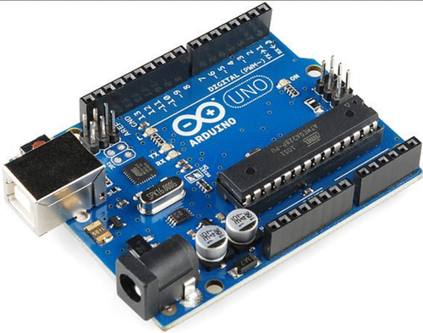

Figure 1: ARDUINO UNO ATMEGA 328

**PROJECT / RESEARCH OUTCOME**

**HUMIDITY IN ADDITION TO TEMPERATURE SENSOR:**

This is a focal temperature and viscosity sensor-driven with very little effort. Capacitive humidity sensors and thermistors are used to check for trapped air. Then it outputs a screen signal that passes through the material pin. BMP 280 Pressure Sensor: This sensor has high accuracy and ease of use, making it the perfect solution for accurate pressure estimation. Weight varies with height and the weight estimate is very accurate.

**BMP 280 PRESSURE SENSOR:**

With its high accuracy and ease of use, this sensor is the perfect solution for accurate pressure estimation. Weight varies with height and the weight estimate is very accurate.

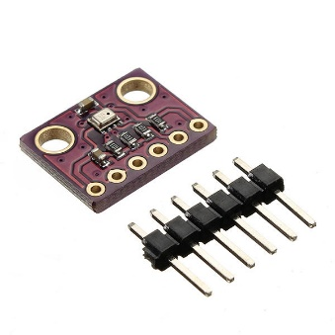

Figure 2: BMP 280 PRESSURE SENSOR

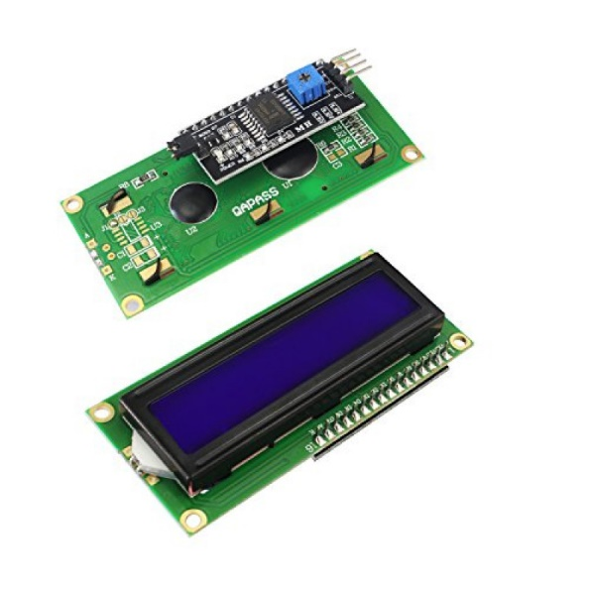

Figure 3: LCD DISPLAY

**GAS SENSOR (FIGARO TGS822):**

It is a electricity display case module that uses Liquid Gem to provide a clear image to the. This is usually a required module Used in DIY and circuits. 16 * 2 uses a platform with 16 fonts for each of these two lines.

Figure 4: GAS SENSOR (FIGARO TGS822)

**WORKING:**

The gas sensor detects CH3) 2CO from the respiration of the human body. This is sent to the data distribution unit of the effort module where the Arduino is located. By, Arduino yields will be proven to LCD or distant zone authorities. The BMPP 280 Weight Sensor measures temperature, weight, and humidity. The sensor gets the yield because the simple sign is the yield. This yield was switched to automation and was displayed on the LCD using the Arduino ATMEGA328P.

Figure 5: DISPLAYING THE PROJECT MODEL

**PROPOSED TIME DURATION**

**REFERENCES**

[1] Z. Mian, K. L.Hermayer, A. Jenkins, "Continuous Glucose Monitoring: Review of an Innovation in Diabetes Management", The American Journal of the Medical Sciences Vol. 358, pp: 332-339, Issue 5, November 2019

[2] A. Rghioui, J. Lloret, M. Harrane, A. Oumnad. “A Smart Glucose Monitoring System For Diabetic Pateint”. Electronics.9 (4), 678, 2020.

[3] N. M. S. Kumar, T. Eswari, P. Sampath, and S. Lavanya, “Predictive Methodology for Diabetic Data Analysis in Big Data,” ProcediaComput. Sci., vol. 50, pp. 203–208, Jan. 2015

[4] Ahmed, H.B.; Serener, A. Effects of External Factors in CGM Sensor Glucose Concentration Prediction. Procedia Compute. Sci. 2016, 102, 623–629

[5] Dr Saravana Kumar N M, Eswari T, Sampath P and Lavanya S,” Predictive Methodology for Diabetic Data Analysis in Big Data”, 2nd International Symposium on Big Data and Cloud Computing,2015

[6] Dost Muhammad Khan1, Nawaz Mohamudally2, “An Integration of K-means and Decision Tree (ID3) towards a more Efficient Data Mining Algorithm”, Journal Of Computing, Volume 3, Issue 12, December 2011.

[7] Luca Catarinucci, Danilo de Donno, Luca Mainetti, Luciano Tarricone, An IoT Aware Architecture for Smart Healthcare Systems, IEEE Internet Things J. 2 (6) (2015) 515–526.